My Choice for CNN Hero 1 of 3
March 7, 2017
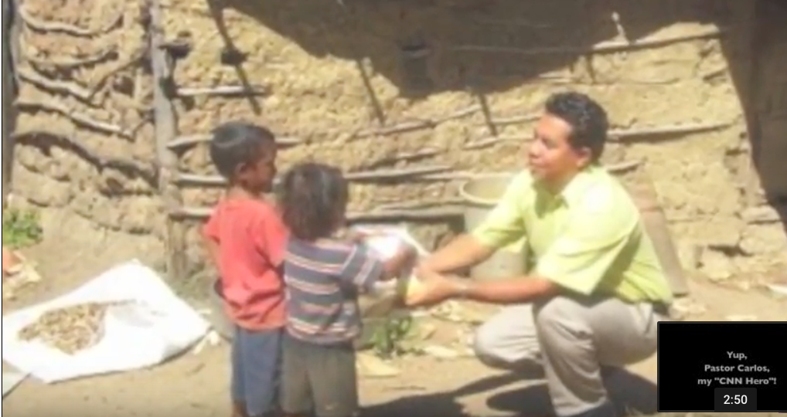
Erik the Flutemaker Presents:
My Choice for CNN Hero

While traveling with Lulu (his puppet monkey) in Nicaragua, I found a man I wanted to help. Pastor Carlos "On the Roads of Love".

Established 557 feeding centers.
Helping disabled kids.
Rescued kids from a garbage dump.
Built them a home.
Started a farm.
Pastor Carlos touching Nicaragua.
Yup, Pastor Carlos, my "CNN Hero"!

